**Day 2- Assignment 3:**

**------------------------------------------------------------------------------------------------------------------------------------------**

**Problem:** Research and compare SDLC models suitable for engineering projects.

**Solution**:

Present findings on Waterfall, Agile, Spiral, and V-Model approaches, emphasizing their advantages, disadvantages, and applicability in different engineering contexts.

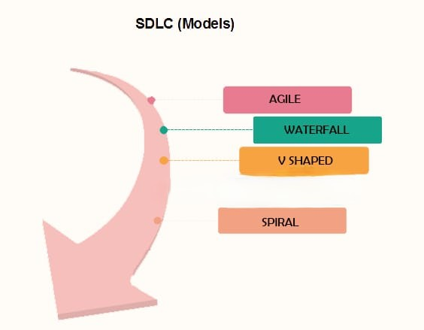

**1. Waterfall Model**:

Overview:

The Waterfall Model is a linear and sequential approach where each phase must be completed before the next begins. It is divided into distinct stages such as requirements, design, implementation, verification, and maintenance.

Advantages:

- Simplicity and ease of use: Clear structure with well-defined stages.

- Documentation: Extensive documentation ensures clarity and understanding.

- Control: Easy to manage due to its rigidity and clear milestones.

Disadvantages:

- Inflexibility: Difficult to accommodate changes once a phase is completed.

- Late testing: Testing phase comes after development, making it hard to backtrack and fix issues.

- *Assumes stable requirements*: Not suitable for projects where requirements are expected to evolve.

*Applicability*:

- Best for projects with well-understood requirements and low risk of changes, such as manufacturing or construction projects where phases are clearly defined and sequential.

2. Agile Model

*Overview*:

Agile is an iterative and incremental approach that emphasizes flexibility, customer satisfaction, and continuous improvement through small, incremental releases

*Advantages*:

- *Flexibility*: Easily accommodates changes and new requirements.

- *Customer feedback*: Regular interaction with customers ensures the project meets their needs.

- *Early delivery*: Incremental releases allow for early and continuous delivery of valuable software.

*Disadvantages*:

- *Less predictability*: Project scope and timeline can be less predictable.

- *Requires active user involvement*: Successful implementation depends on consistent and active stakeholder engagement.

- *Overhead*: Frequent meetings and reviews can introduce additional overhead.

*Applicability*:

- Ideal for projects where requirements are expected to evolve, such as software development, and for teams that can closely collaborate with stakeholders, ensuring regular feedback and adjustment.

3. Spiral Model

*Overview*:

The Spiral Model combines iterative development with systematic aspects of the Waterfall Model, focusing on risk assessment. It involves repeating cycles (spirals) where each cycle addresses a set of objectives, risks, and stakeholder feedback.

*Advantages*:

- *Risk management*: Focuses on early identification and mitigation of risks.

- *Flexibility*: Iterative approach allows for adjustments based on feedback.

- *Customer feedback*: Regular review cycles ensure alignment with customer needs.

*Disadvantages*:

- *Complexity*: Managing iterative cycles can be complex and challenging.

- *Cost*: Potentially higher cost due to continuous risk assessment and prototyping.

- *Requires expertise*: Effective risk analysis requires skilled personnel.

*Applicability*:

- Suitable for large, complex, and high-risk projects such as aerospace engineering or innovative software products where risk management and adaptability are crucial.

#### 4. V-Model (Verification and Validation Model)

*Overview*:

The V-Model is an extension of the Waterfall Model, emphasizing verification and validation. Each development phase is associated with a corresponding testing phase, forming a V-shape.

*Advantages*:

- *Emphasis on testing*: Early development of test plans reduces the risk of defects.

- *Clear structure*: Provides a disciplined approach with well-defined stages and deliverables.

- *Easy to manage*: Clear milestones and responsibilities enhance project control.

*Disadvantages*:

- *Inflexibility*: Similar to Waterfall, it is difficult to accommodate changes once a phase is completed.

- *Late testing feedback*: Issues may only be discovered during the testing phase, leading to potential rework.

- *Requires stable requirements*: Not well-suited for projects with evolving requirements.

*Applicability*:

- Effective for projects with clear, stable requirements and a high emphasis on quality assurance, such as safety-critical systems in medical devices or automotive software where validation and verification are paramount.